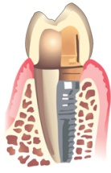

DR. BRENDA FOWLER
PRACTICE LIMITED TO PERIODONTICS

Periodontal Plastic Surgery
Regenerative Therapy
Dental Implants
866-667-4867

ACKNOWLEDGEMENT OF RECEIPT
OF NOTICE OF PRIVACY PRACTICES

*You May Refuse to Sign This Acknowledgement*

I, __________________________________________, have received a copy of this
office’s Notice of Privacy Practices.

___________________________________________
Signature

_____________________________________
Date

FOR OFFICE USE ONLY
We attempted to obtain written acknowledgement of receipt of our Notice of Privacy Practices,
but acknowledgement could not be obtained because:
o Individual refused to sign
o Communications barriers prohibited obtaining the acknowledgement
o An emergency situation prevented us from obtaining acknowledgement
o Other (please specify)

____________________________________________________________________________

